STUDENT HANDOUT HTML-CHAPTER2
HTML TABLES
About Workshop:
In this workshop, We'll cover everything from the basic structure of an HTML table to more advanced topics like adding headers, formatting cells, and incorporating tables into your job portal web application. In this chapter, we are divided into five workshops, each of which illustrates how to effectively utilize these elements in your application. You can also make use of the previously learned tags.
The Scrum Master can divide the workshop among team members, and you can proceed to walk through the tasks assigned to you.

WORKSHOP1:

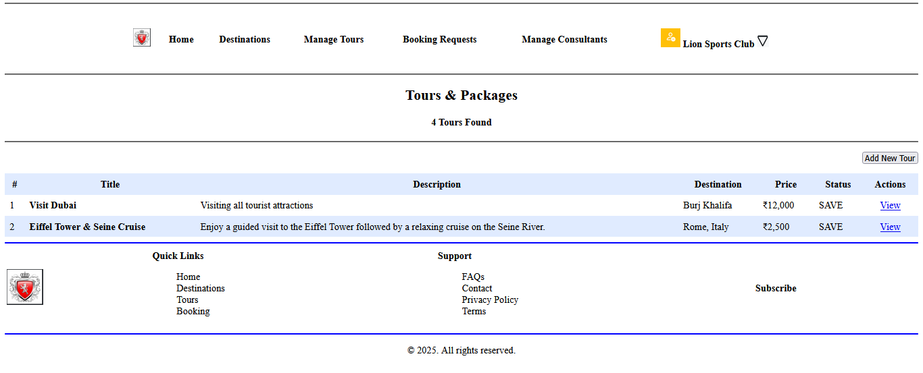

Expected output:- 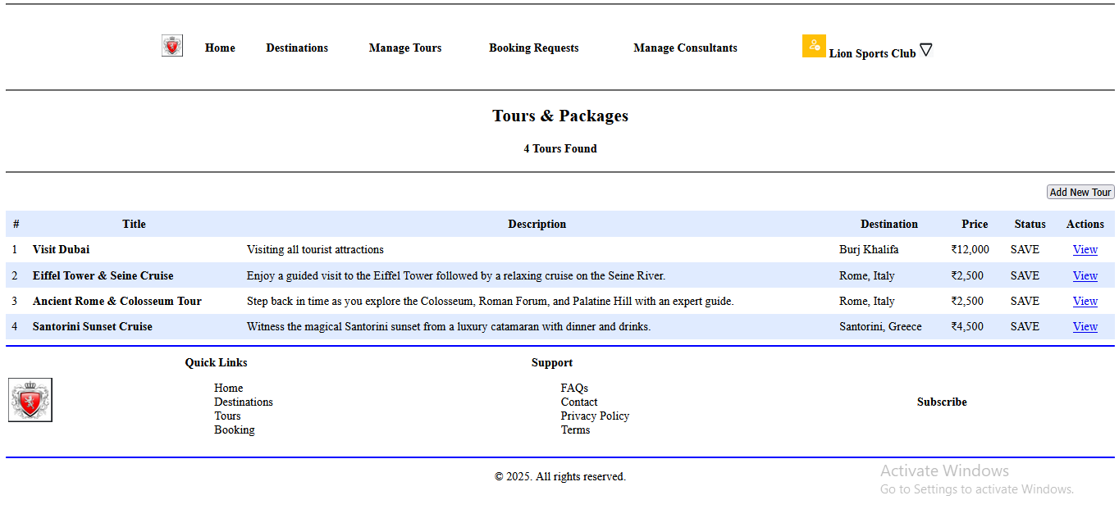

On this page, using the <table> tag to create a structured layout for a web page , dividing it into rows and columns where content like text and images can be placed. The attributes(width,cellpadding,cellspacing,bgcolor,colspan,rowspan) and tags (<table>,<tr>,<td>,<th>)within the table are used to control the appearance and arrangement of this content on the page. , let's incorporate a content section as two rows in our table, further enhancing the structure and completeness of our tables.

WORKSHOP2:
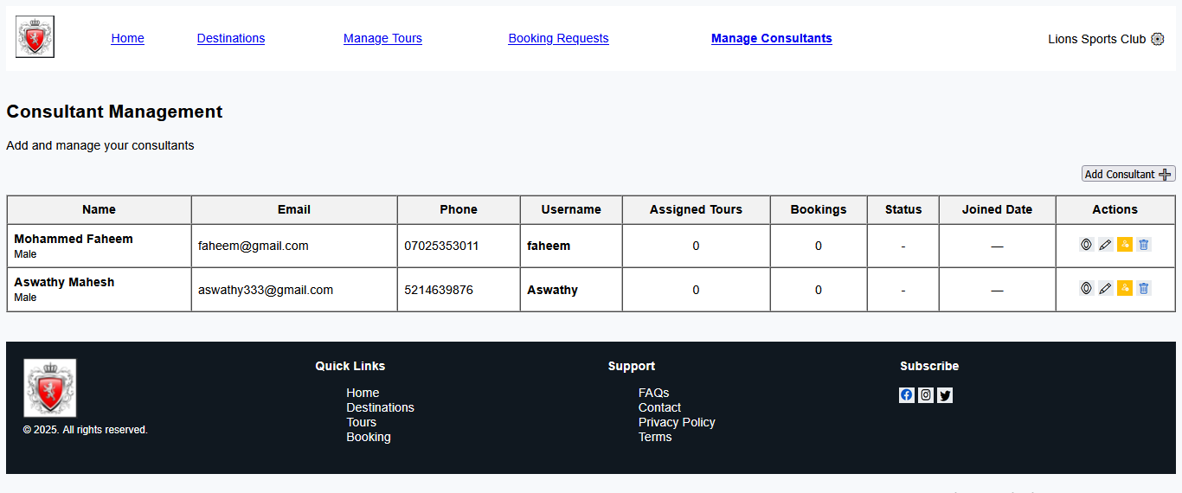
Expected output:-
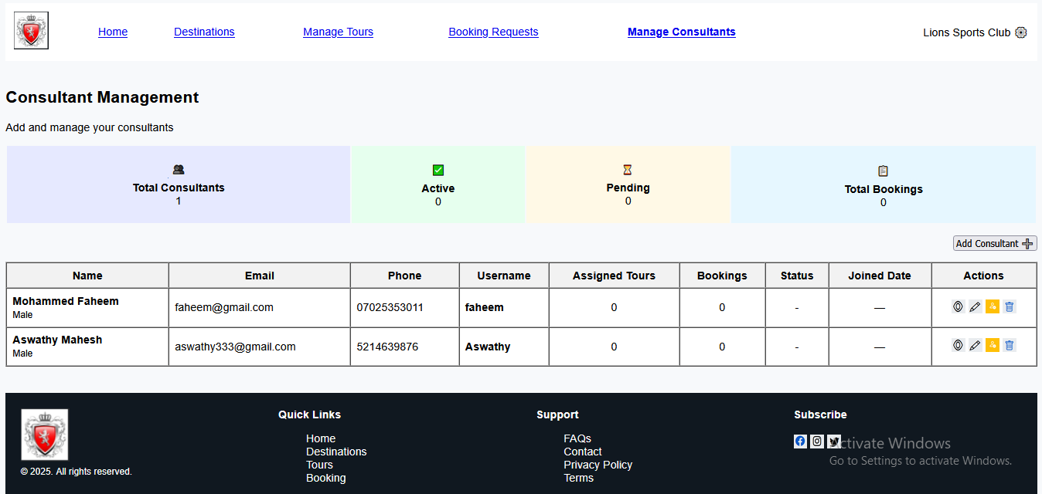
In this page, we can learn how to create a table, add table headers (<th>), add table rows (<tr>), and insert the corresponding table data (<td>). We can also set attributes like height and width for the table, rows, and data cells as per our requirements.

WORKSHOP3:
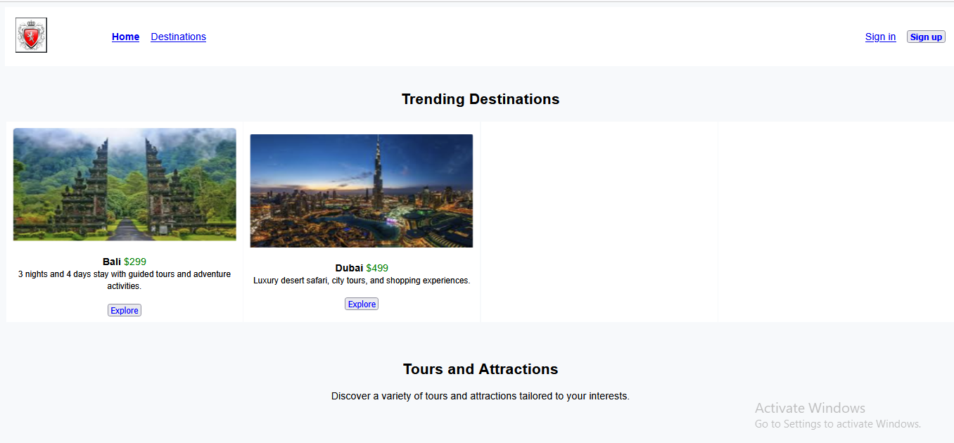

Expected Output:
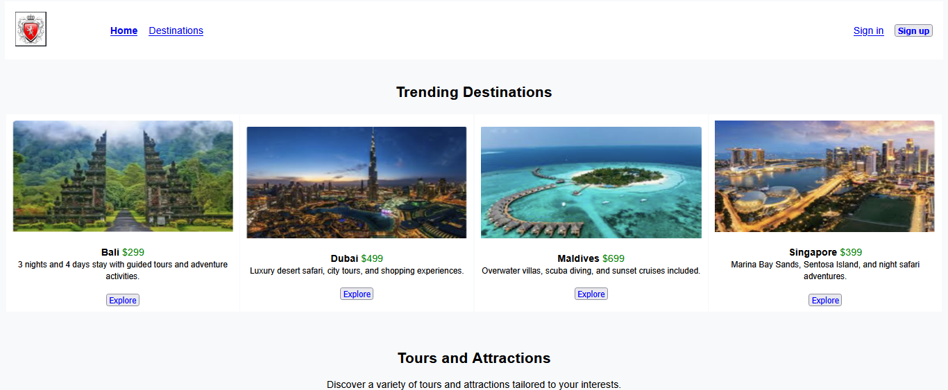

In this workshop, we have constructed a table and added a row. The destinations were added here, and we also need to add two more destinations.

WORKSHOP4:
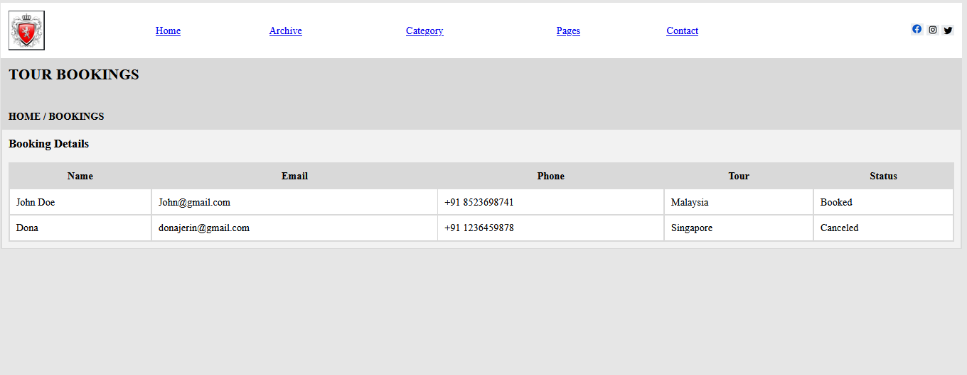

Expected Output:
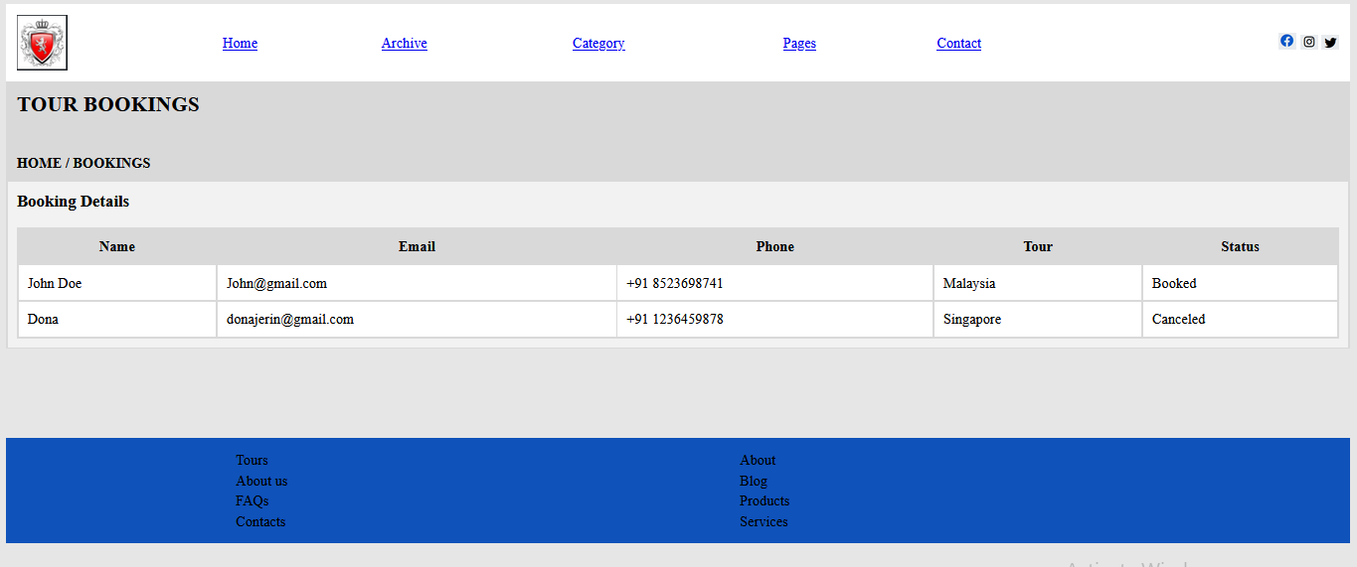
During this workshop, we will be constructing a JobProviders page for Platform Admin. On this page, using the <table> tag to create a structured layout for a web page , dividing it into rows and columns where content like text can be placed. The attributes (width, cellpadding, cellspacing, bgcolor,colspan,rowspan) and tags (<table>,<tr>,<td>,<th>)within the table are used to control the appearance and arrangement of this content on the page. , let's incorporate a content section as two rows in our table, further enhancing the structure and completeness of our tables.

